JONA BOOKS |  | Pre- PUBLICATION ORDER FORM
HOOYAH! UDT/SEAL STORIES OF THE 1960’s

By Nick Nickelson
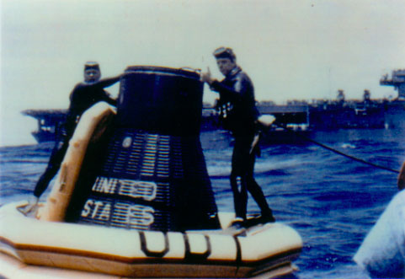 | CLASSIFICATION  AUTHOR  RETAIL PRICE  PUBLISHER  DIMENSIONS |  | Nonfiction/Military  Nick Nickelson  $24.95  joNa Books  5.5 x 8.5 Hardcover. 200 pages. Photos.

SYNOPSIS

A NEW BOOK FROM “JoNa BOOKS” CONTAINING 30 STORIES AND 20 PICTURES RELATED TO NAVAL SPECIAL WARFARE AND THE MEN WHO BELONGED TO THE NAVY’S ELITE UDT/SEAL TEAMS DURING THE 1960’s.

SOME STORIES ARE HUMOROUS AND SOME ARE NOT BUT EACH STORY IS INTENDED TO SHOW A SIDE OF BASIC UNDERWATER DEMOLITION SEAL (BUDS) TRAINING AND LIFE IN THE TEAMS NEVER BEFORE EXPOSED TO THE GENERAL PUBLIC. THESE ARE STORIES TEAM MEMBERS HAVE BEEN TALKING AND LAUGHING ABOUT FOR YEARS; THEY ARE STORIES OF THE MEN WHO MADE THEM POSSIBLE.

ABOUT THE AUTHOR

NICK NICKELSON WAS A MEMBER OF THE NAVY’S ELITE UDT/SEAL TEAMS DURING THE 1960’S AND IS CURRENTLY CHAIRMAN OF “THE KENNY NICKELSON MEMORIAL FOUNDATION FOR HOMELESS VETERANS AND CHILDREN, INC.” (KNMF). KNMF IS NON-PROFIT, TAX-EXEMPT 501©(3)

CORPORATION. ALL PROCEEDS ATTRIBUTED TO THE AUTHOR OF THIS BOOK WILL GO DIRECTLY

TO KNMF.

JoNa Books’ Return Policy  If you're not fully satisfied with your purchase, you may choose to return it for a full refund. |  |  | Contacting JoNa Books  By Mail: ……………………….… PO Box 336, Bedford, IN 47421  By Phone/Fax: …...…(812) 278-9512 fax (812) 278-9518
 |  |  | By Email:……………………………………….. jonabook@kiva.net
© 2004 by Nick Nickelson  ISBN: 1932673288 |  |  | On the Web……………….……… http://www.jonabooks.com
- Please rush me my personal copy of HOOYAH! UDT/SEAL Stories of the 1960’s
Name:_____________________________________ address: _______________________________________________
_________________ City: _______________ State: _______ ZIP:_______ Phone: (_____)___________________
Make checks payable to:  The Kenny Nickelson Memorial Foundation |  | PRICE QUANTITY SUB-TOTAL
To contact KNMF: Phone: (310) 545-2937  Fax: (310) 939-7738 E-Mail: nicknmf@adelphia.net  Mail orders to:  KNMF  P.O. Box 3098  Manhattan Beach, CA 90266 |  | $24.95ea X_______ =_________  Add Shipping and Handling @ $5.05: _________  TOTAL PRICE: _________  AMOUNT ENCLOSED: _________

